Jesus and the Father
Reading: from Luke 15:11-20
Jesus said, “There was a man who had two sons. The younger son spoke to his father. He said, ‘Father, give me my share of the family property.’ So the Father divided his property between the two sons.
Not long after that, the younger son packed up all he had. Then he left for a country far away. There he wasted his money on wild living. He spent everything he had. Then the whole country ran low on food. So the son didn’t have what he needed.
Then he began to think clearly again. He said, ‘How many of my father’s hired servants have more than enough food! But here I am dying of hunger! I will get up and go back to me father. I will say to him, ‘Father, I have sinned against heaven. I have sinned against you. I am not longer fit to be called your son. Make me like one of your hired servants.’ So he got up and went to his father.
While his son was still a long way off, his father saw him. He was filled with tender love for his son. He ran to him. He threw his arms around him and kissed him. He said, ‘Let’s have a feast and celebrate> This son of mine was dead. And now he is alive again. He was lost and now he is found.’”

Thought about the reading
What do you think God is like? Some people think he is always angry. Jesus told this story to show what God the Father is like.
In the story, the youngest son takes half of the father’s money and spends it having a good time. When the money runs out, he has nothing to eat. He decides to go back home and see it he can get a job as one of his father’s servants. They have lots to eat.
The father has been watching and waiting for his son to return. That is how much he loves him. He welcomes him back not as a servant, but as his son.
Jesus told this story because the religious leaders criticised him for welcoming and eating with sinners – people who had done wrong. Jesus showed them that the Father loves each of us, no matter what we have done, and he is always watching and waiting for us to turn to him.

Prayer
Dear Father in heaven, thank you that you love us even when we don’t deserve it. Thank you that you are watching and waiting for us to turn to you.
Please help me to love you in return.
Amen

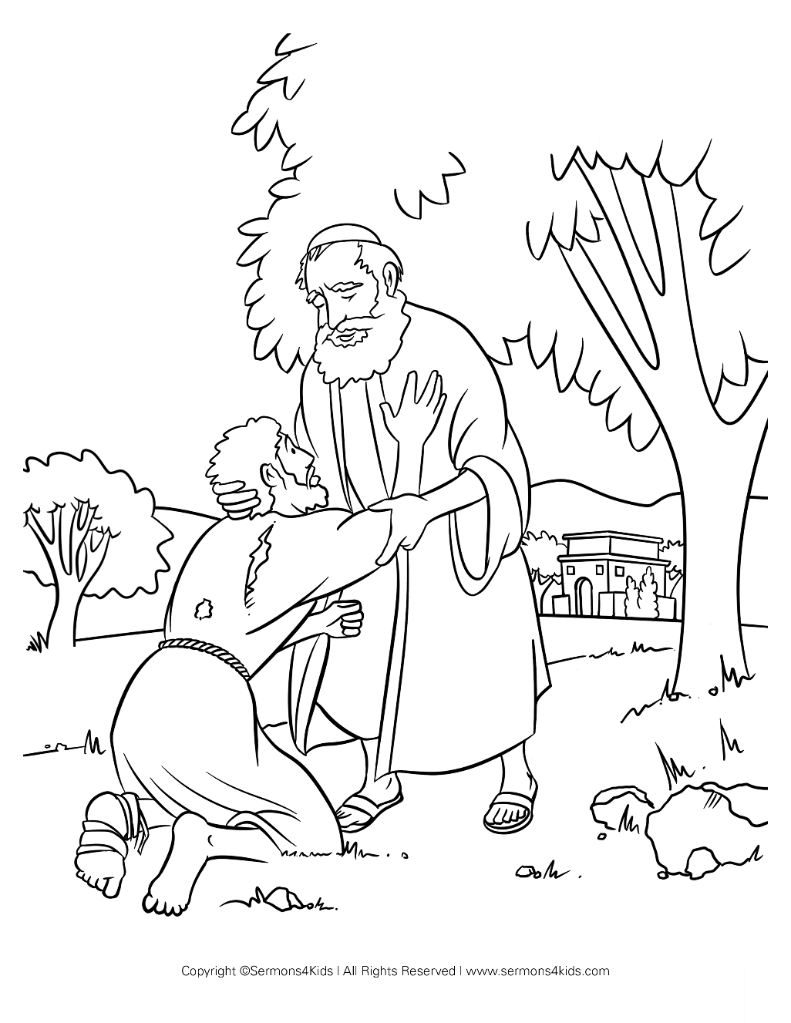

Cambridge Causeway

Autumn 2025
Bible Study notes

Jesus the Reason
3. Jesus and the Father
By Chrissy Cole

